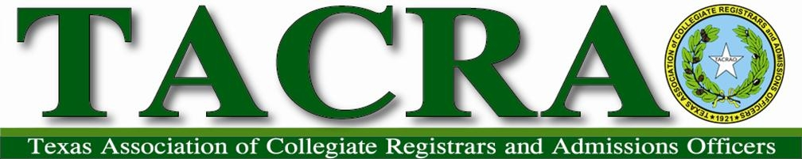

November 9, 2020
Annual Conference (Virtual)
Honorary Membership and Recognitions Awards Committee Report

Nominations for Honorary Membership and Recognition awards were solicited via the TACRAO listserv using an online form submission. The following nominations were received:

Four naming John Hall, retiree from Southern Methodist University
Two naming Laura Divine, retiree from College of the Mainland

NOTE: Two additional nominations were received for individuals who have already been awarded Honorary Membership (Richard Jimmerson and Wanda Munson).

Based upon TACRAO points earned during their time of service to the organization:
- John Hall (289 points) was recommended and approved by the committee and forwarded to the TEC for final approval for “Honorary Membership”.
- Laura Divine (40 points) was recommended and approved by the committee and forwarded to the TEC for final approval for a “Certificate of Commendation Upon Retirement”.

The committee arranged for video recording of the presentations due to the virtual nature of the annual conference as a result of COVID19. These videos were provided to TEC in lieu of an in person presentations.

Respectfully submitted,

Tana J. Miller, Chair, West Texas A&M University
Joe Papari, Southern Methodist University
Lee Owens, Navarro College

